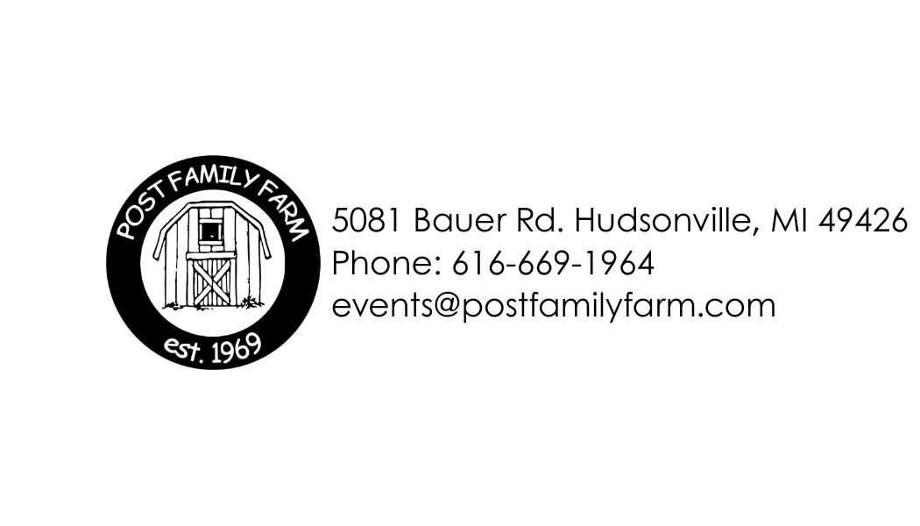
Post Family Farm

Fall Guest Appreciation Event

PC SS RB GC don form IT Event Day Date Advertised Event Time Staff Arrival Time Donuts Served from to
Thank you for reserving our Farm for your event! We offer a unique, beautiful, and private setting along with professional, yet family-like, service. Be our guest and make your event unforgettable!
Contact Person Organization
Phone Alternate Phone Email address
Type of Group: Families Adults Total in Group
Package Options - Available the day after Labor Day through October 31
Weekdays Monday-Thursday, 3:30pm-7:30pm (wristband package required)
Package includes a welcome table near the front entrance to greet guests upon their arrival and perhaps offer donuts and cider! We will track the number of wristbands issued and invoice you following your event.

Wristbands $9/person (under 2 free)
Wristbands include Corn Maze, Pumpkin Train Rides, Playground Area, Tube Slides, Straw Climb, Corn House, Spider Web, Hayride to the Pumpkin Patch, access to Farm Animals and more!
$75 Reservation Fee: Includes one covered area to enjoy donuts and cider with your guests. Note: Limited
seating – for events requiring seating for more than 25 at a time, please refer to our Facility Rental Form.
Pavilion (overlooking waterfall) Lean-to (overlooking activity area)
Weekends Friday 3:30pm-7:30pm, Saturday 10am-7:30pm (wristband package required)
Package includes a welcome table near the entrance to greet your guests upon their arrival and perhaps offer donuts and cider! We will track the number of wristbands issued and invoice you following your event.

Wristbands $12/person (under 2 free)
Wristbands include Corn Maze, Pumpkin Train Rides, Playground Area, Tube Slides, Straw Climb, Corn House, Spider Web, Hayride to the Pumpkin Patch, access to Farm Animals and more!
$75/hour for rental of the upstairs of the 2000 Barn (animal barn) as a covered area. Note: Limited seating – for
events requiring seating for more than 25 at a time, please refer to our Facility Rental Form.
Certificate-only Package: Price based on # of redeemed certificates
Allows your guests to enjoy the Farm when it is convenient for them. You create certificates for your guests to redeem during our regular business hours. Note: Certificates must be submitted to us and approved before distributing. Feel free to reach out if you would like editable template options.

Package Upgrades – We will track any of the upgrades you choose and invoice you following your event.
Homemade Donuts $17/dozen Served at welcome table covered area
Cold Cider Approx. $12/gallon (market value) Served at welcome table covered area
Hot Cider Add $8/gallon - Served only at the covered area
Table Linens $7/each
Pony Rides $7/ride – Saturdays only
Apple Cannons $5/bucket of apples - You create Apple Cannon Cash ($5 each) to give to your guests.
Pumpkin Bucks Value $
You create Pumpkin Bucks (any $ amount off) to give your guests towards the purchase of pumpkins.
Note: You must provide the Pumpkin Bucks – coupon value and the name of your organization are required (template options available upon request).
SPECIAL INSTRUCTIONS:
***Note: Prices subject to change unless we have a completed reservation form; 3% surcharge on credit cards.***

